**High Speed with an LED**

Very high-speed photography (>1000 fps) requires two things: A lot of light and a lot of money (for the camera). While obtaining the latter can be difficult, acquiring the former has become much easier. Modern LED sources are comprised of multiple LED chips on a board (COBs). Recently, LED COBs with high efficiency and good color temperatures have become much more common and hence inexpensive. This makes them excellent choices for high intensity lighting. In addition to their efficiency, they are much more compact and emit far less IR radiation (which causes undesirable heating) than high lumen incandescent or halogen sources. 100W COBs can be found for as little as $2.50 (plus shipping). These units can produce near 10,000 lumens (lm), which is equivalent to a 400-600W halogen lamp. A COB can easily produce more than 4 times the lumens/Watt of an incandescent or halogen light source. Lastly, COBs are DC devices, which means their emitted light intensity can be made as steady as you wish.

**The Build –** We need power, heat dissipation, mobility, and focusing.

**Power**

Naturally, the power source must match the LED wattage for maximum output. Also, LEDs work better with a current source rather than a voltage supply (consider the I-V curve for a diode). So we need current in the 3-3.5A range, with a voltage between 32-35V. The quickest and easiest way to power your COB is to buy a ready-made LED driver, but it is cheaper and gives you more options to use a boost converter fed by a 12-24V wall powered voltage supply. This will allow you to swap the wall supply with a battery if you want to make your source portable. Note that additional circuitry will be necessary for Lithium Polymer (LIPO) batteries because they should never be completely depleted. 12V mobility cart batteries are good options if you want to go this route. The github link below has a few schematics for building your own boost circuit, but it is actually more cost efficient to buy one (ebay, Alibaba, Amazon).

**Heat Dissipation**

Modern desktop CPUs require 50-150W of heat dissipation, which is right around the level needed to prevent premature death of your 100W COB therefore, any modern CPU heatsink (from a discarded desktop PC) will likely work. For this project we used a Coolmaster hyper 212 heatsink that was left over from a previous project. These heatsinks have 4 heat pipes and a 120mm fan, which must be operating to provide the necessary dissipation. If you wish to use 500W LED COBs, you will need water-cooling.

**Mobility**

The 120mm fan is perfect for attaching a custom handle, which can be 3D printed using the stl file that can be accessed at the github below. The handle also includes a slot for a ¼-20 nut that enables attachment to a tripod. It can be made even more mobile with a battery as noted above.

**Focusing**

To focus the light we designed a parabolic reflector that mates well with the hardware kit included with the heatsink. Depending on how you print the reflector you may want to smooth the surface for reflective paint or tin foil. The LEDs will output a fair amount of radiant heat that can melt plastic given enough time, so choose your material wisely. To further focus the light, you can add an optional lens for around $3. It produces a little color distortion, which can be removed by blocking the outer edge of the COB with an opaque heat resistant material.

All stl files and circuit layouts are available at the link below. Feel free to comment or add your own modifications to the github repository

<https://github.com/penoel/100W-LED-Light-Source>

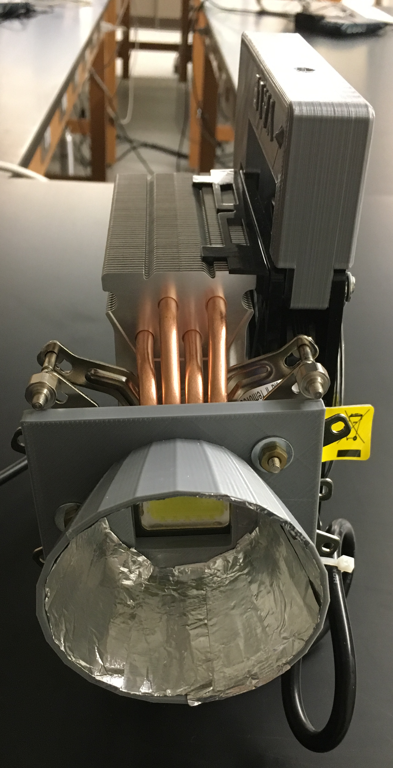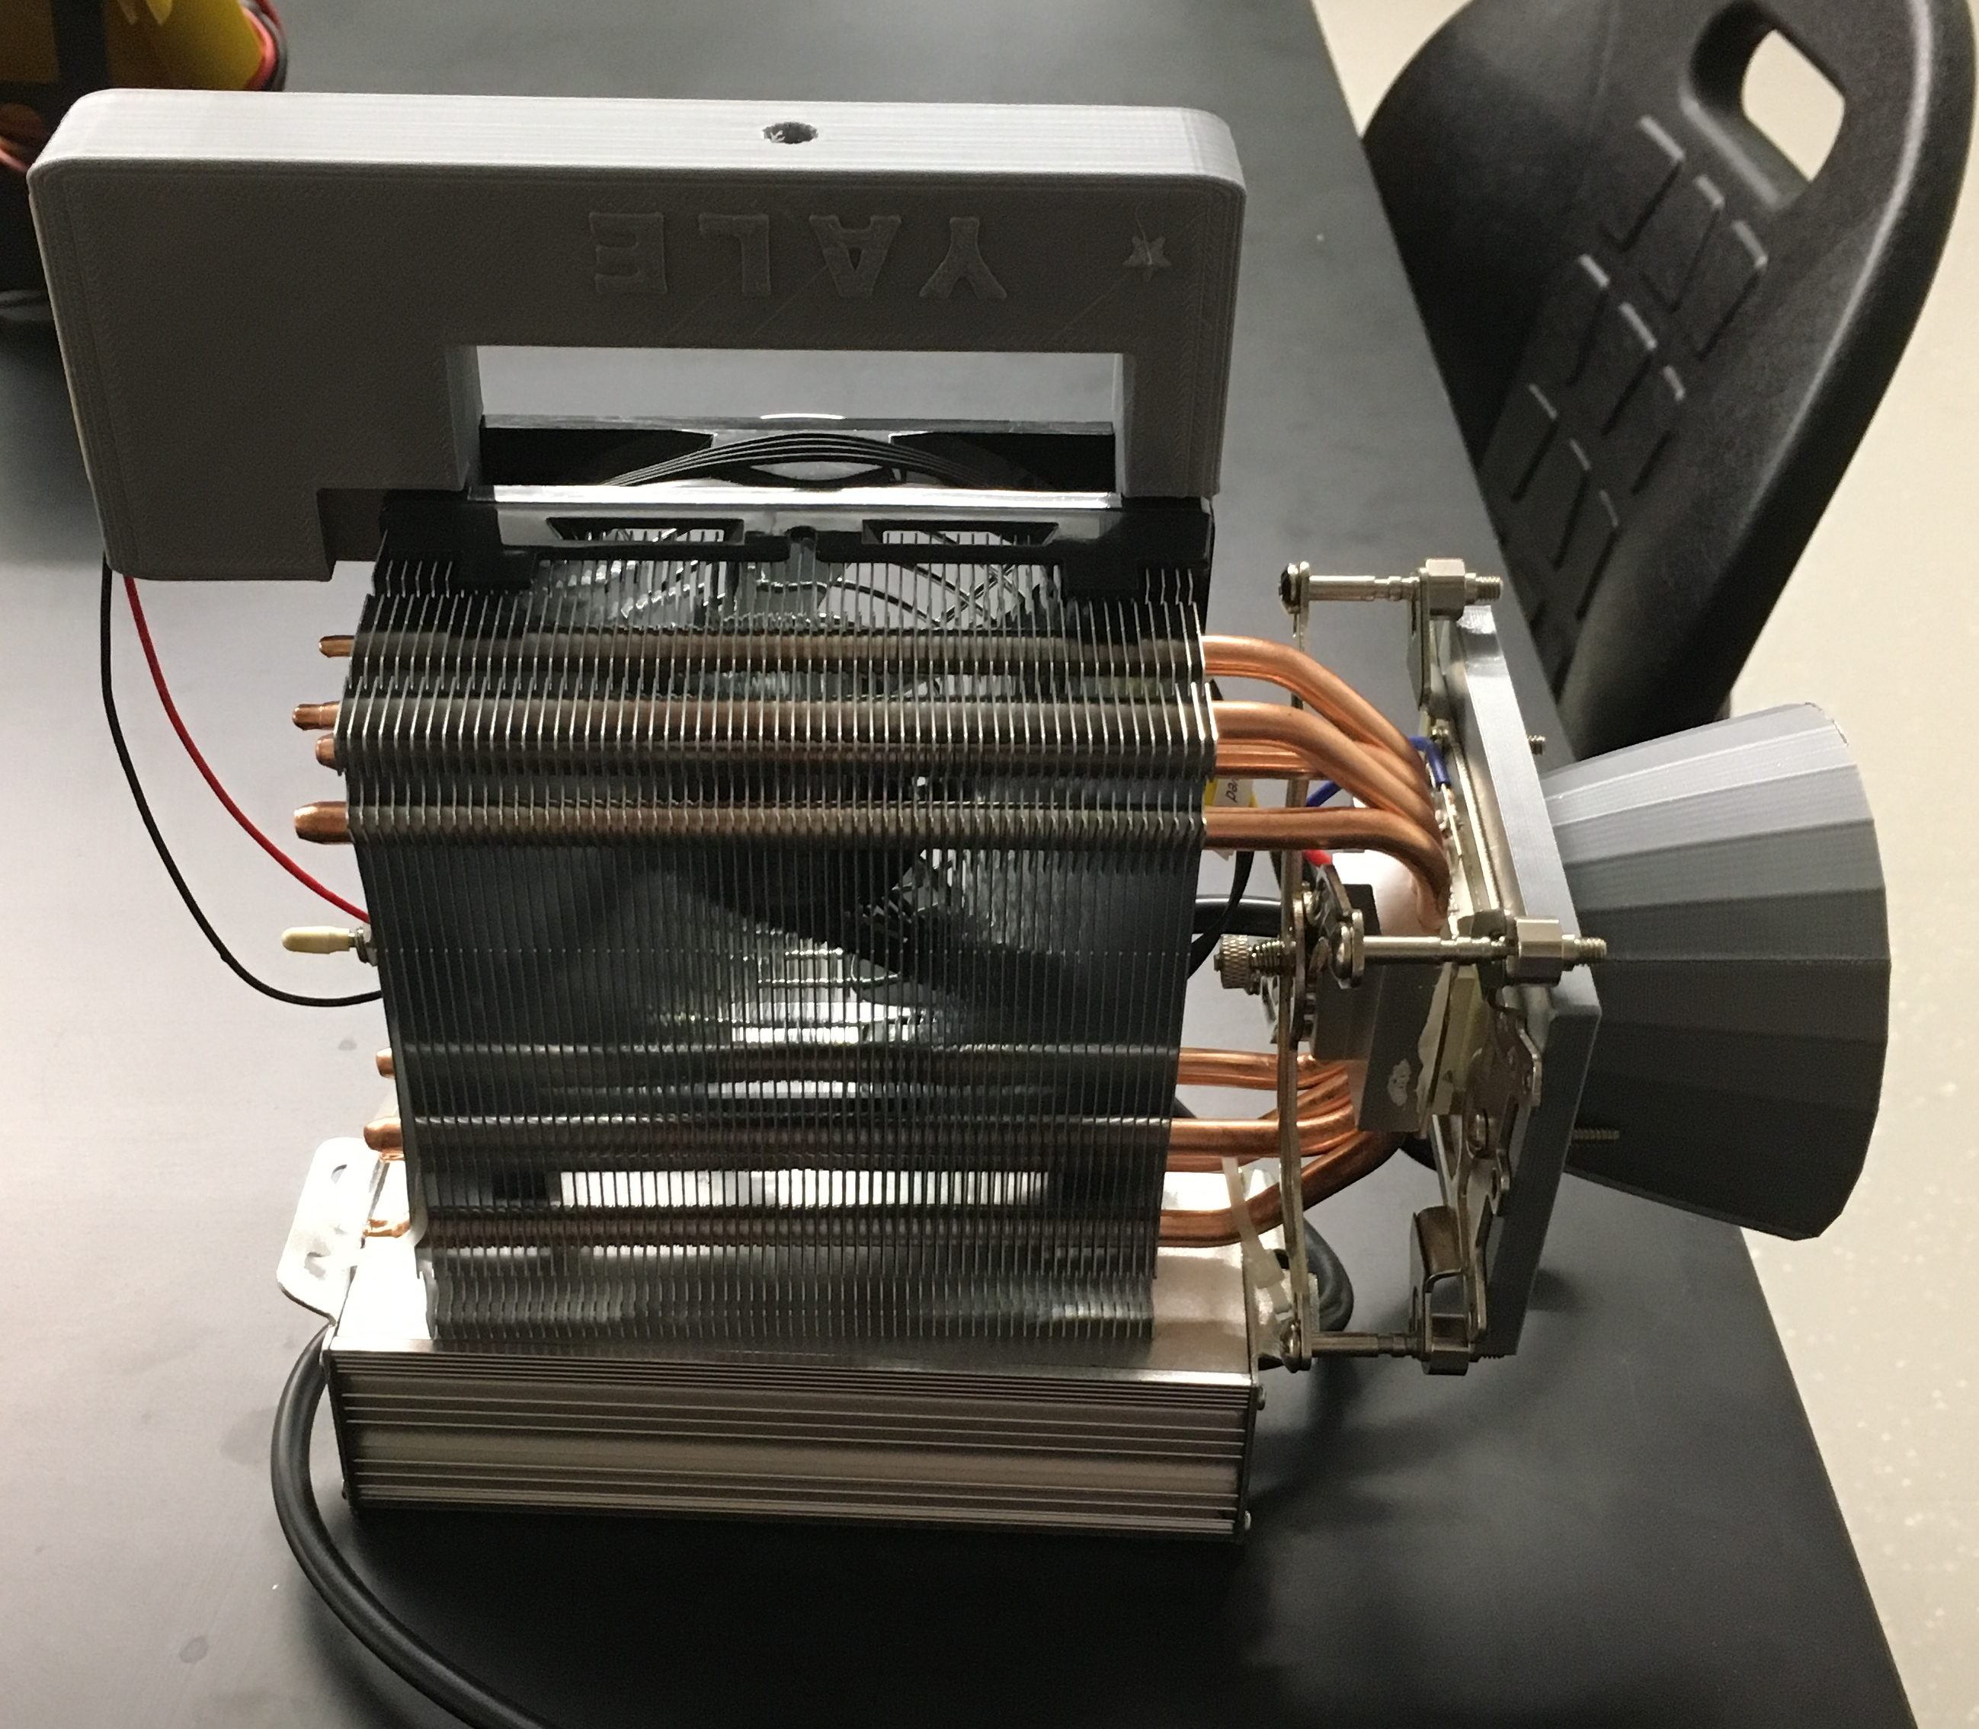

Front and side view of source showing the reflector, LED (inside the reflector), heat sink (with attached fan), handle and power supply. This light source will allow you to easily film indoors at 5000 frames/second (200 µseconds/frame) with light to spare. With two such sources you can access even faster processes with little problem.

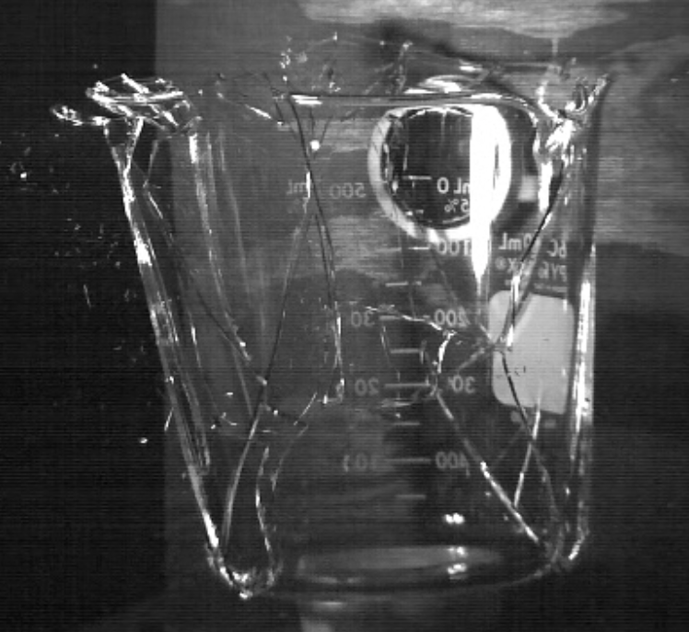

Single frame from a video of a beaker shattered with resonant sound taken at 5000 frames/second Using a single 100W LED COB.  
Camera: RedLake MotionPro HS-4